**Logo**

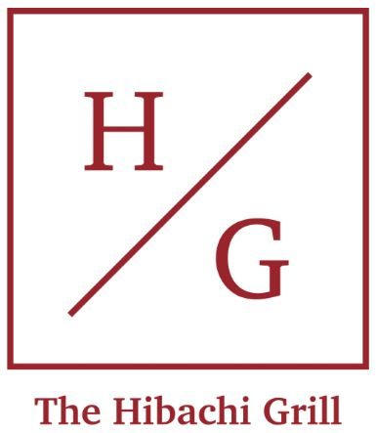We want a logo that is both simple elegant to express the pure and top-quality ingredients of our restaurant. We have created this logo to make it easier for our customer to recognize the brand.

H and G stands for **H**ibachi **G**rill.